**SE4433/CMSC5433 Software Architecture and Design**

**A Web-based Search Engine**

**Assignment 3**

Cameron Llewellyn and Kyle Miller

Process Architecture: The team member communicated through text message. Their work schedules are opposite so it made it hard to set a time to work on the assignment together. The work was divided up with Kyle doing the diagrams and cleaning up code, and Cameron doing the work to change the previous code into the client/server/database style. The code and diagrams were passed back and forth for checking and correcting because the team members are hardly ever awake at the same time.

Use case diagram: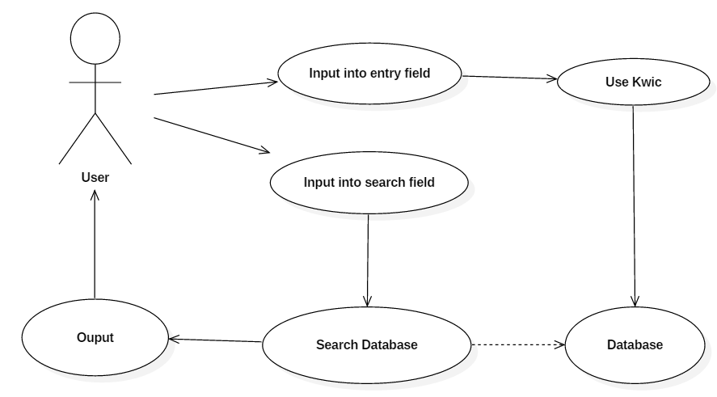

Class diagram:

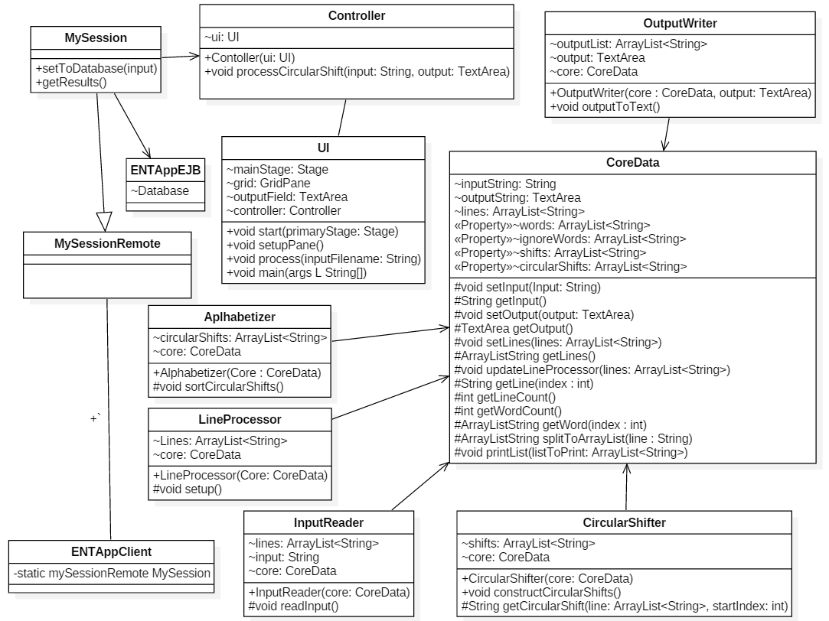

Component Diagram:

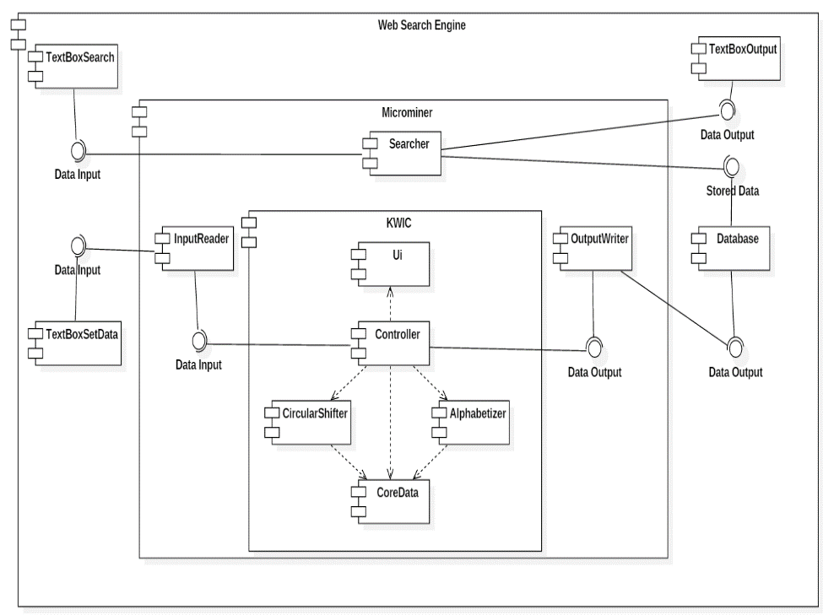

Deployment Diagram:

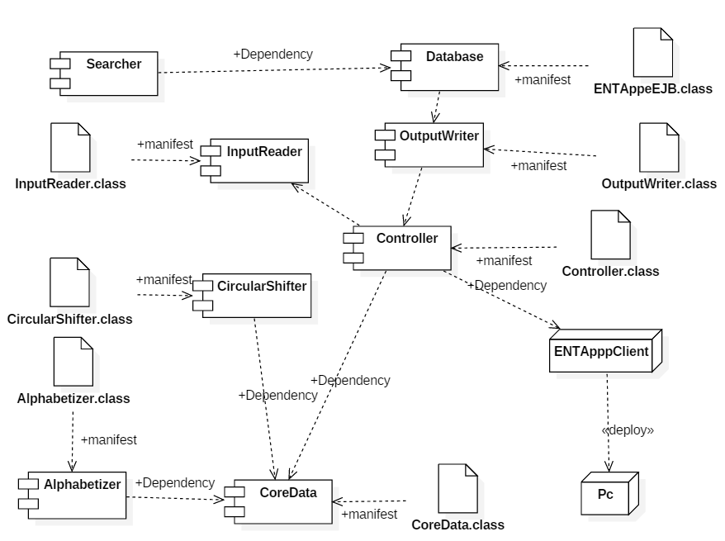

User Manual:

Upon starting the application the user is presented with three text boxes, labeled as (Input data to database here.), (Enter search terms here.), and (Results will be shown here.)

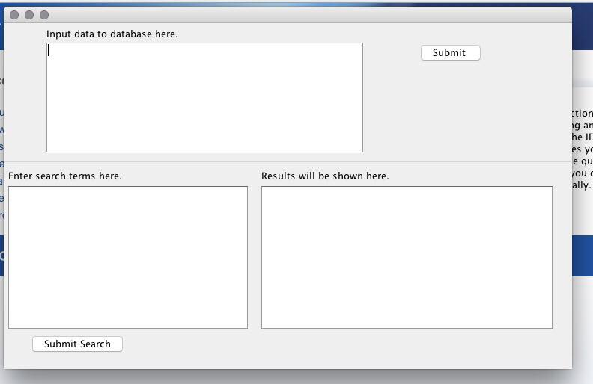

The user in the current application must start at the (Input data to database here.) textbox since the app does not start with data in the database. The user must enter data into the data base in the format of title then website link with multiple entries spaced with presses of the enter key (returns). Once the user has supplied sufficient data in the text box the user must press the Submit button to the right of the current text box to put the data in to the database for searching. The user may then move to the (Enter search terms here) text box and enter search terms to be search for. After pressing the (Submit Search) button the program will find the results with matching keywords. The next few examples will use the test case below.

University of Central Oklahoma http://www.uco.edu

University of Oklahoma http://www.ou.edu

Arizona State University http://www.asu.edu

Oklahoma State University <http://www.osu.edu>

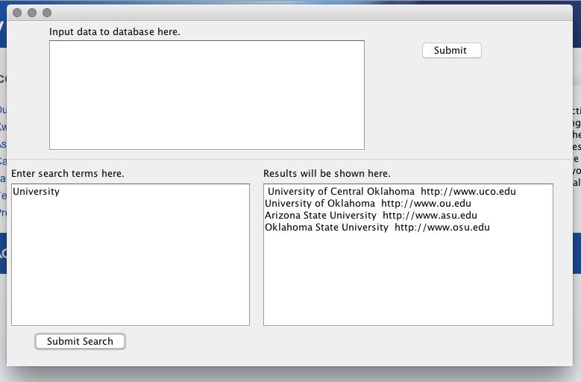

As shown above, typing “University” with the given case will return all result containing the word university. This also works for typing in multiple words. As shown below typing in the two keywords “Oklahoma” and “University” will supply all results with both the word “Oklahoma” and “University” included in them.

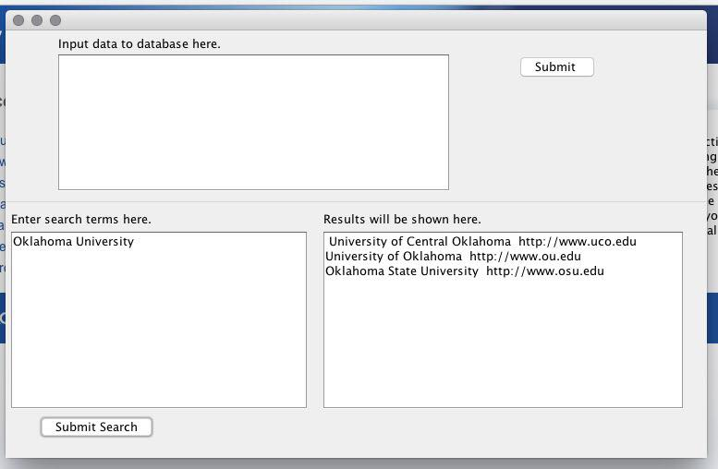

This concludes the user manual.